Welcome to:

# Unit 5: Mobile Communication Network Design

After completing this unit, you should be able to:

1. Understand the concept of Mobile IP
2. Learn Mobile IPv4 Operations
3. Understand Cellular and WLAN Integration
4. Understand handoff in integrated network architecture.

This unit covers the following topics

Mobile IP, functionalities of mobile IP, Route Optimization techniques, Cellular and WLAN Integration, Heterogeneous Network Architecture, Handoff in integrated network architecture.

* **Purpose:** To provide introduce audience towards GSM architecture, GSM spectrum, Channels , call flow and handover
* **Audience:** Students who have basics of Analog and Digital Communication
* **Perquisite:** Fundamentals of Analog and Digital Communication
* **Course objectives:**

1. Understand the concept of Mobile IP
2. Learn Mobile IPv4 Operations
3. Understand Cellular and WLAN Integration
4. Understand handoff in integrated network architecture.

* Concept of Mobile IP
* Basic entities for MIPv4
* Mobile IP Operation
* Mobile IP Type-MIPV4 and MIPv6
* Mobile IP Process
* Route Optimization
* Cellular and WLAN Integration Architecture
* WLAN-Cellular Handover (Mobile IP)

-Wireless LANs and cellular networks

* + provides Wireless connectivity
    - provides Mobility at the data link layer

Dynamic Host Configuration Protocol (DHCP)

-It provides local IP addresses for mobile unit

* + - not secure

- do not maintain network connectivity when moving around

Limitations:

* + Do not provide Transparent connectivity at the network layer
  + Do not provide Mobility with local access

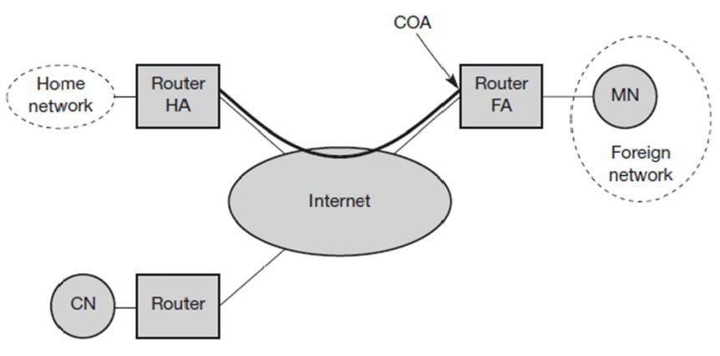

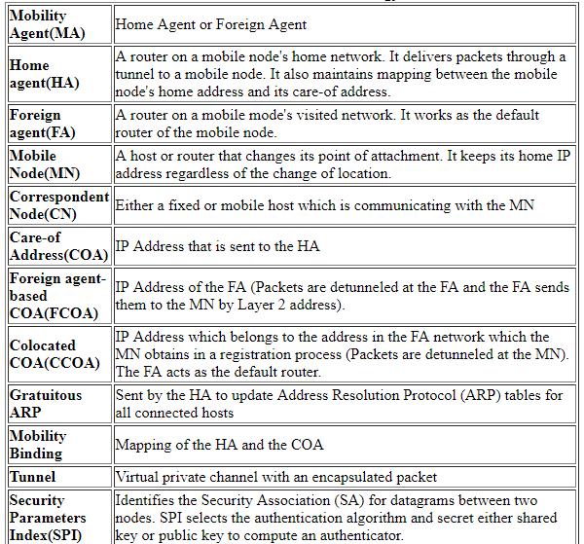

* network layer mobility is supported in Mobile IP
* seamless roaming opportunities across the network.
* home network gets ‘‘Extended’’ across the entire Internet

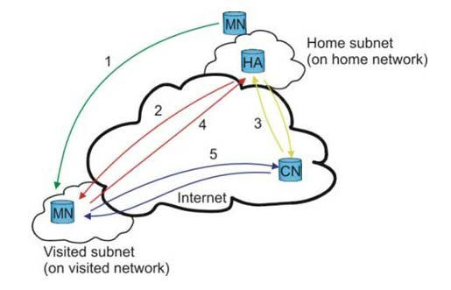

# Mobile IP Operation

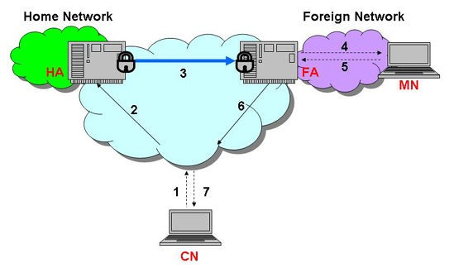

# Internet Protocol Version 4 Vs Version 6

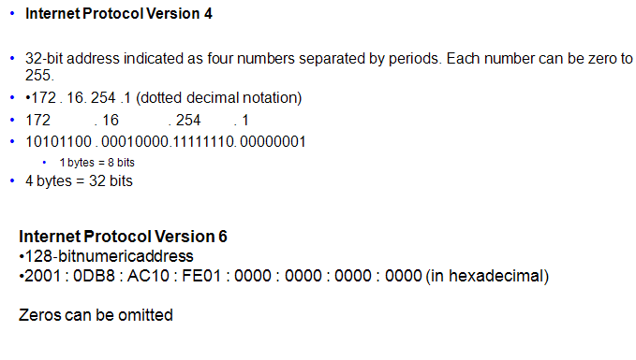

# Mobile IP Type-MIPV4 and MIPv6

**IBM ICE (Innovation Centre for Educati**

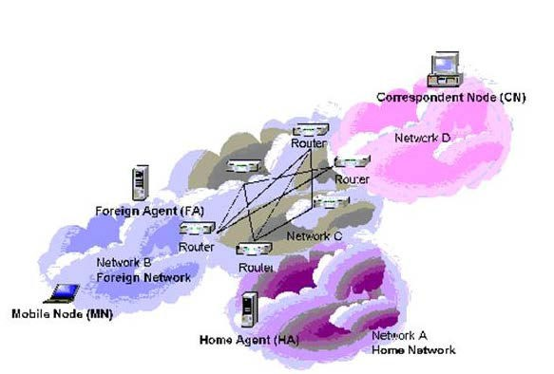

## Fig: mobile IP over IPv4.

# Comparison

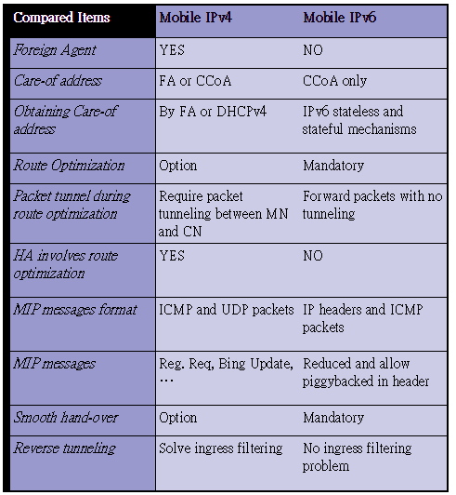

# Mobile IP Functionality

## Location Discovery

* **Move Detection**
* **Tunneling**

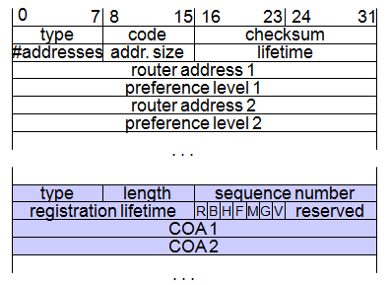

MN FA HA

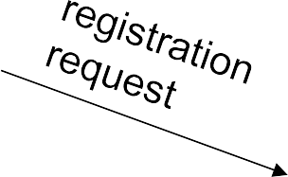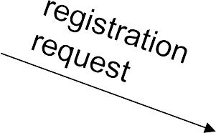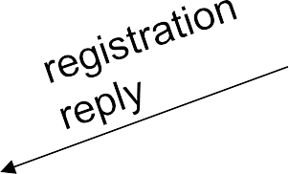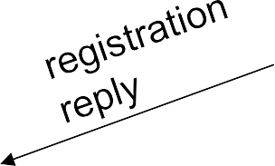

MN HA

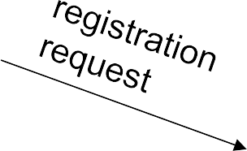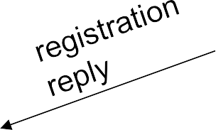

extensions . . .

|  |  |  |  |  |  |  |  |  |  |
| --- | --- | --- | --- | --- | --- | --- | --- | --- | --- |
| 0 7 | 8 15 | | | | | | | 16 23 | 24 31 |
| type | S | B | D | M | G | V | rsv | lifetime | |
| home address | | | | | | | | | |
| home agent | | | | | | | | | |
| COA | | | | | | | | | |
| identification | | | | | | | | | |
|  | | | | | | | | | |

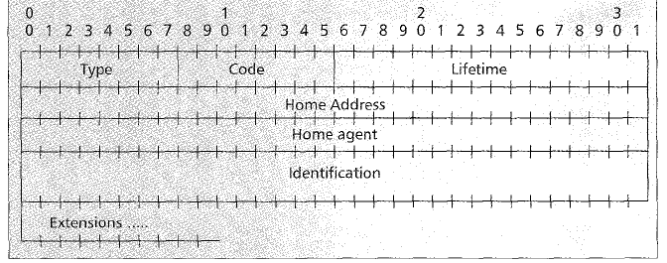

Registration Reply format

# 

# Tunneling Architecture

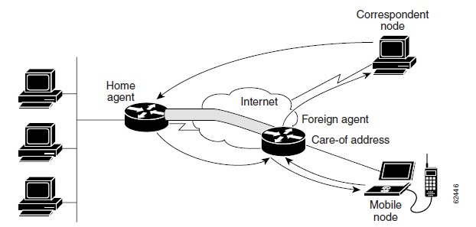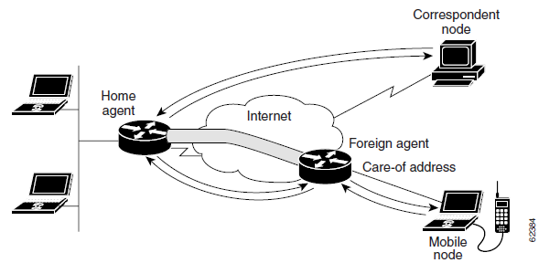

Packet forwarding

Reverse Tunnel

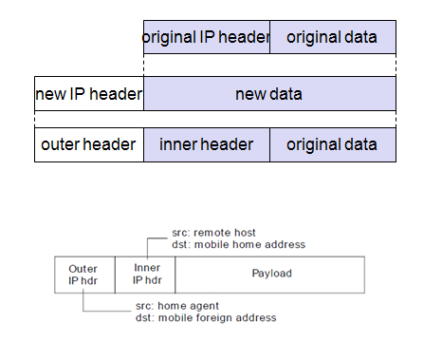

* **Triangle Routing:**

**-** It is simplest form as all packets go to home network (HA) and then sent to MN via a tunnel.

* + involves two IP routes which needs to be set-up, one original route and the second the tunnel route.
  + Limitation: unnecessary network overhead results in latency.
* **Route optimization:**

**It** allows the correspondent node to learn the present location of the MN through which tunnel its packets directly.

* + mobility: correspondent node has to update/maintain its cache.
  + authentication: HA has to interact with the correspondent node to do authentication for every registration

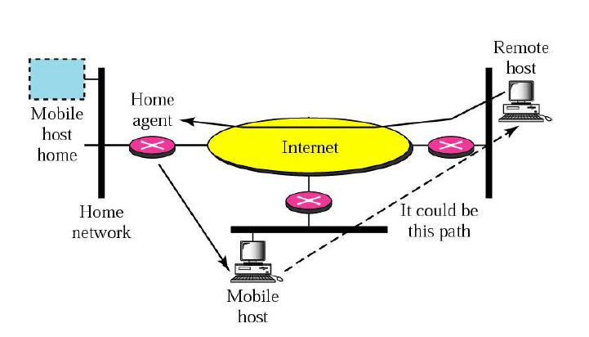

Source: Forouzan TCP /IP Protocol suite

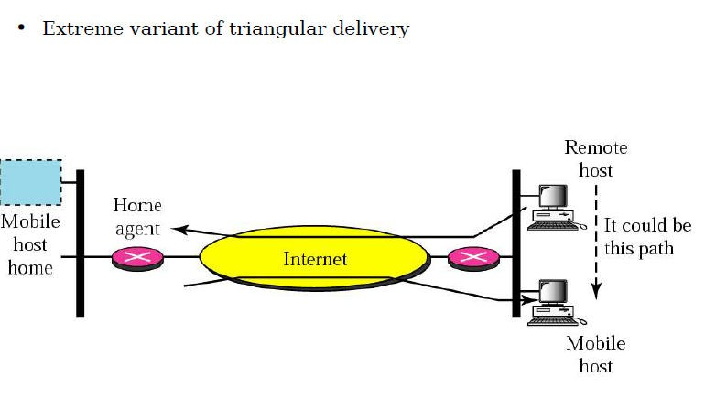

* Triangle routing has the MN correspond directly with the CN using its home address as the SA
  + Firewalls at the foreign network may not allow that
  + Multicasting: if a MN is to participate in a multicast group, it needs to use a reverse tunnel to maintain its association with the home network.
  + TTL: a MN might have a TTL that is suitable for communication when it is in its HM. This TTL may not be sufficient when moving around (longer routes possibly). When using a reverse tunnel, it only counts as a single hop. A MN does not want to change the TTL everytime it moves.
* **Solution:** reverse tunneling

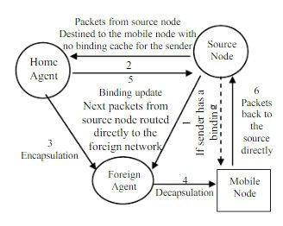 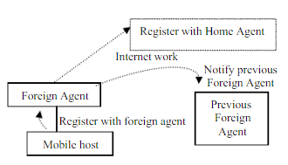

**Route Optimization Smooth handoff during registration**

Source: <http://www.academia.edu/5684554/Triangle_Routing_Problem_in_Mobile_IP>

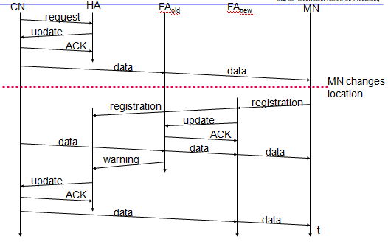

* **Route optimization using dynamic address allocation in Mobile IP**

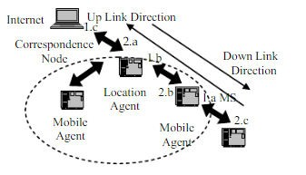

Source: <http://www.academia.edu/5684554/Triangle_Routing_Problem_in_Mobile_IP>

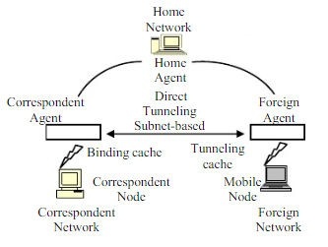

“Source”“<http://www.academia.edu/5684554/Triangle_Routing_Problem_in_Mobile_>

~~IP”~~

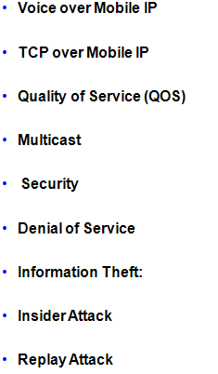

* • Objective is to keep bit rate higher than 100 Mb/s
* • Need to exploit WLAN technology and integrate into mobile data network
* Capable of ubiquitous data service and y high data throughputs in hotspot locations
* • A Tight Coupling Architecture • A Loosely Coupled Architecture

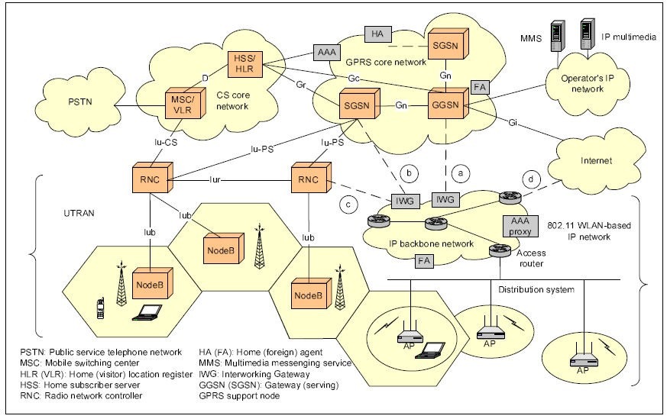

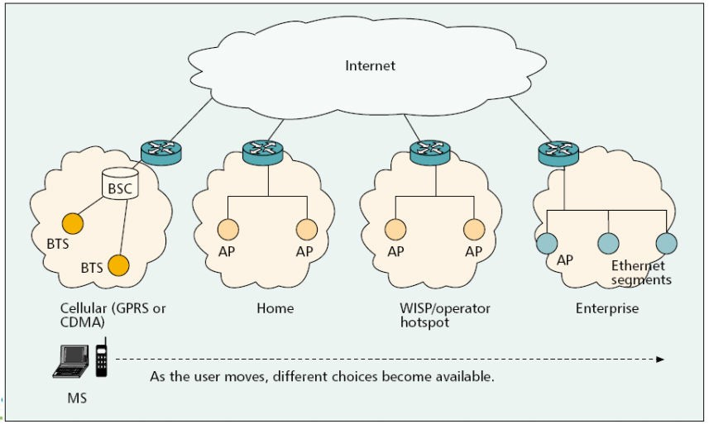

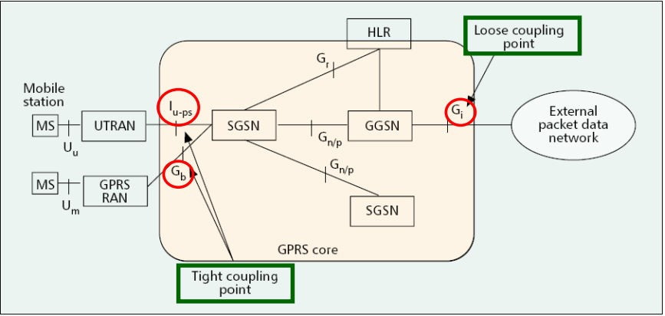

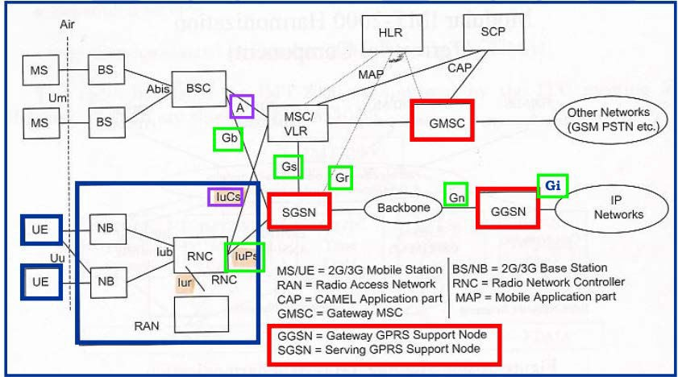

* Objective is to support Common customer care and billing
* Radio Access control and charging as per 3GPP policy
* Radio Access 3GPP and GRPS-based service
* Providing Service continuity and improve QOS
* Seamless services for the subcribers
* Radio Access to 3GPP and circuit-switched services such as Voice

# WLAN-GPRS Tight Coupling

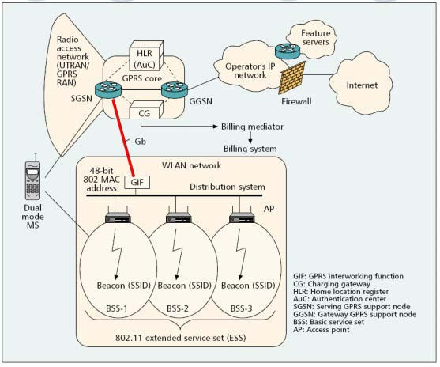

* “WLAN-GPRS Integration with Loose Coupling: System Configuration”

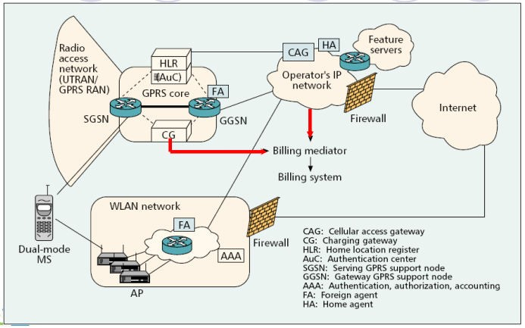

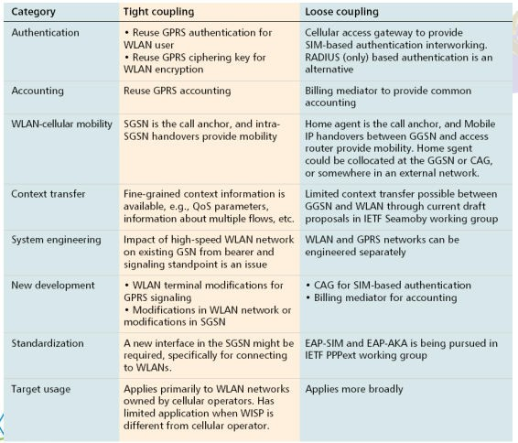

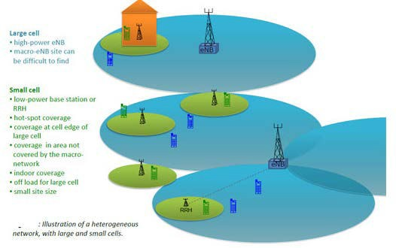

“Source: <http://www.3gpp.org/technologies/keywords-acronyms/1576-hetnet>”

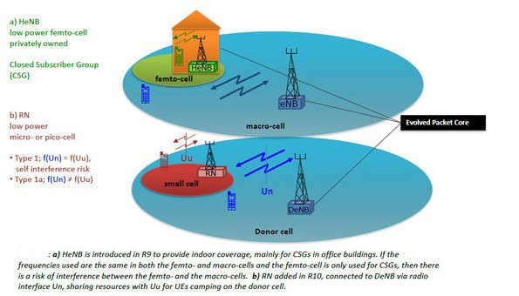

“Source: <http://www.3gpp.org/technologies/keywords-acronyms/1576-hetnet>”

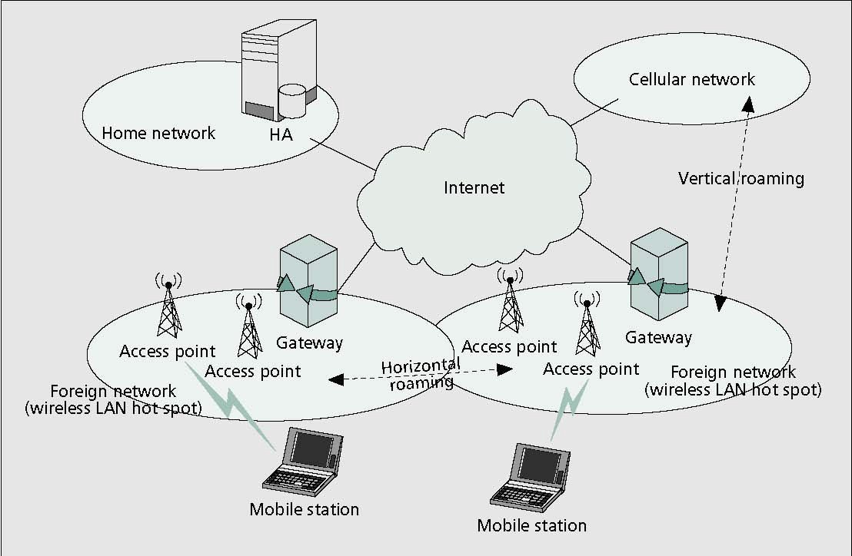

Web Server

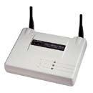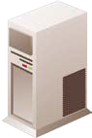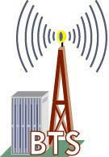

Home Address: 192.10.10.10

Care-of-Address (Cellular)

68.10.10.10

**Cellular Network**

MIP Home Agent

**Internet**

**WLAN**

**System**

Registration

Tunnel Setup

Tunnel 192.10.10.10 to 68.10.10.10

Web Server



Home Address: 192.10.10.10

Care-of-Address (WLAN) 104.10.10.10

**Cellular**

**Network**

MIP Home Agent

**Internet**

**WLAN**

**System**

Registration Tunnel Setup

Tunnel 192.10.10.10 to

104.10.10.10

## Having completed this unit, you should be able to:

1. Differentiate various Mobile communication Standards
2. List the features of WLAN and 802.11 standards
3. Highlight the Significance of IP Mobile Technology and its features
4. Understand how IP is used in 4G Technology
5. Compare BSS / OSS operations and its application in Telecom Industry

